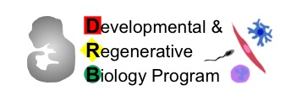
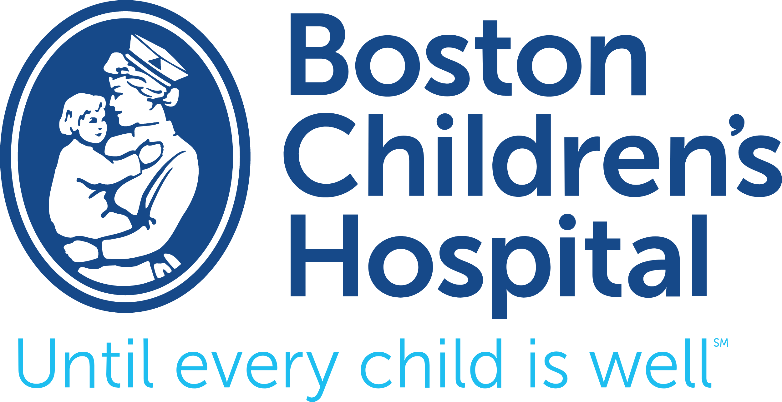
DRB Professional Development Awards
Cover Page
Application due September 30th at 5pm

These awards are meant to fund activities that not only promote the student's professional development, but also promote, develop or otherwise benefit the student’s laboratory or principle investigator. Activities could include, but are not limited to, conference travel, workshop attendance, course enrollment, and educational materials such as books. Funds may not be used for personal expenses such as computers, iPads, etc. Food is also not a reimbursable expense.

Please email mara_laslo@hms.harvard.edu if you have any questions. Application periods are open for 2-3 weeks each semester, and applicants are notified of results ten days to two weeks after the application deadline. Awards will fund activities taking place no more than six months prior to the application deadline, and no more than one year after it. Preference will be given to applications for activities occurring in the six months after the deadline.

Students can apply an unlimited number of times, but, are eligible to receive the award a maximum of two times during their tenure. Each award is given in the form of a reimbursement and will carry a maximum value of $1000.

Please upload the following materials to the online form:

- A brief description of your current research and future career goals.
- A brief description of how you intend to use the award funds, with a specific explanation of how the activity will further your professional development. For instance, if the application is for conference travel, you should indicate what you plan to present (abstract, poster, or other materials), or otherwise support your reason for attending.
- A detailed budget. Include all costs (such as registration, course fees, transportation, lodging, meals, and any other anticipated expenses), not only the portion that may be covered by this award.
- Please provide links to any supporting material. For instance, if the application is for a course please provide a link to the syllabus, or provide the website for a conference.
- A statement of other sources of financial support you have applied for and/or received (if applicable).

Applicant Signature: X _____________________________________________________

Ph.D. Advisor Signature: X _________________________________________________

*By typing your name, you are electronically signing this document. By typing or signing your name, you are certifying that you are an enrolled student in the Developmental and Regenerative Biology graduate program*

